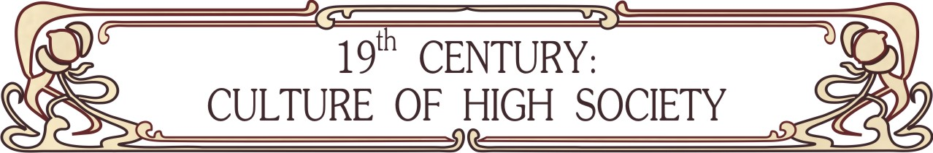
+7 921 307-14-27 (Russia), +420 775 384 510 (Europe)
http://www.xixcentury.com
xixcentury@mail.ru

Price

Arranging balls, literary and music salons, outdoor events in the 19th century style in different countries (program forming, searching halls, musicians, artists, photographers, catering and touristic service) | From 1000 €
Arranging balls (historical, touristic, graduations, weddings, children, corporates and etc) with program | From 100 € / hour
Dance performance | From 50 € / hour / person
Dance classes (historical dances of 1800-1914’s) | From 50 € / hour + to rent of hall
Social lectures about culture and everyday life of nobility (etiquette, history of fashion, persons and their life and etc) | From 100 € / 2 h.
Master-classes (dance classes, practical lessons by historical hairstyle making (1800-1913’s), historical costumes tailoring (features of cut and dressmaking) | From 50 € / hour + to rent of hall
Individual patterns of women’s historical costumes (including undergarments) of 1800-1914’s | From 10 €
Articles about culture and everyday life of nobility | From 10 € / 1000 symb.

All events are available in different countries (in this case travel and hotel accommodation are charged extra).

Warm regards, Maria Dmitrieva

