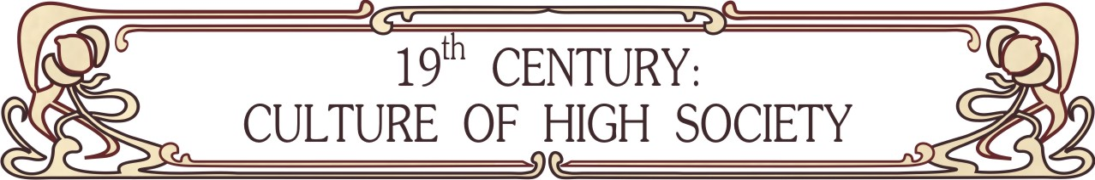
+7 921 307-14-27 (Russia), +420 775 384 510 (Europe)
http://www.xixcentury.com
xixcentury@mail.ru

Dear lady / Dear gentleman,

We would like to offer you culture events in the 19th century style:

- Arranging balls (historical, touristic, graduations, weddings, children, corporates) with easy dances (at first participants are learning all dances, than dance to the music), historical salon and dance-games (different charades, living pictures, brook-dance, gallop and etc), performances (romances, classic music, dances). Usually ball program takes 1-2 hours. Balls can be carrying out in English, Russian and Czech languages, in other languages with an interpreter. Balls are available in Europe, Russia and other countries at your desire;
- Dance classes (historical dance of 1800-1914’s);
- Social lectures about culture and everyday life of nobility (etiquette, history of fashion, famous people and their life and etc). One lecture takes 2 hours.

Look at the photos of our events, look through our list of events and invite us to make “time machine” for you!

Warm regards, Maria Dmitrieva,
project manager

P.S. More information you can find on http://www.xixcentury.com, if you have any questions and offers don’t hesitate to contact us.

